**System Programming**

**Lab01**

**Fall 2024**

Submitted by: **Mohsin Sajjad**

Registration No: **22pwsce2149**

Class Section: **A**

“On my honor, as student of University of Engineering and Technology, I have neither given nor received unauthorized assistance on this academic work.”

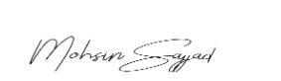

Student Signature: ______________

Submitted to:

**Engr. Abdulla Hamid**

Month Day, Year (05 10, 2024)

Department of Computer Systems Engineering

University of Engineering and Technology, Peshawar